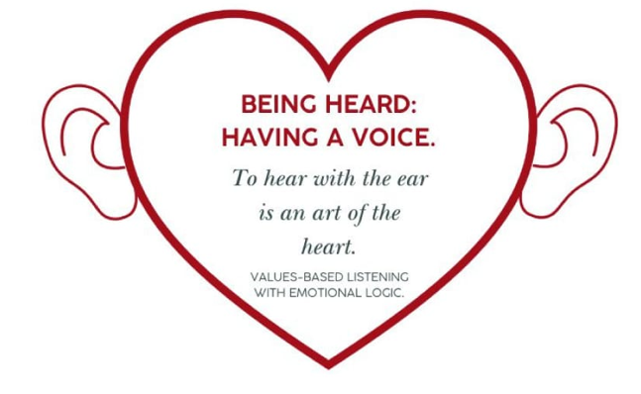
Values based listening with Emotional Logic change the way you listen to people.
Every person has a story to tell. When they leave your office, did they feel heard?
People bring their emotional overload into a consultation. Their overwhelm can pose ethical dilemmas which need careful consideration of our values and healthy boundaries.
In this training your will get a new toolkit to equip clients to understand their emotions. You will gain new perspectives of your own. How does Guilt impact my relationship with God / others?
CPSC, “VBO points for DR Ministers”, ASCHP:
5 points. Five hours video training. Costs: R500

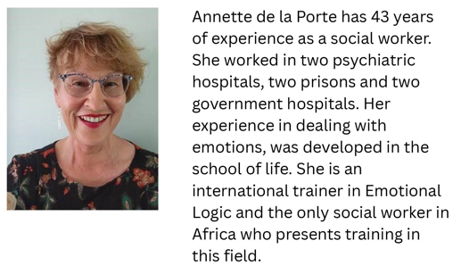
Website: https://growwithannette.co.za/helping-professions-training/ Email address: Annette@growwithannette.co.za

